IIC Calendar Activity
A Overall Report on 3-Days Workshop on Drone Surveying, Mapping & Photogrammetry” On 21-09-2026 to 23-09-2026.
Title of The Event |  | 3-Days Workshop on Drone Surveying, Mapping & Photogrammetry
Resource Person & Details |  | Mr. M. I. Amruth Raj  Drone Survey Trainer Spatial Flytech Solution Pvt. Ltd.
Event Convener/ Coordinator & Details |  | Prof. D.Venkatesh, HOD & Associate Professor,  Department of Civil Engineering,  Narsimha Reddy Engineering College.
Program Type* Please mention any one of the Given Below.  Level 2 - Workshop |  | Level 2 - Workshop
Program Theme * Please mention any one of the Given Below.  1.IPR & Technology Transfer |  | 1.IPR & Technology Transfer
Start Date :  End Date :  Duration of the activity : |  | 21-09-2026  23-09-2026  09.00 AM to 04.00 PM
Mode of Session |  | Offline
Number of Student Participants * |  | 90
Number of Faculty Participants * |  | 10
Objective of The Event |  | The primary objective of this three-day workshop was to introduce students to modern drone-based surveying and photogrammetry techniques used in Civil Engineering. The workshop aimed to:  - Develop awareness of UAV and drone surveying technologies.  - Train students in flight planning and safe drone operations.  - Understand aerial data acquisition using photogrammetry.  - Generate orthomosaic maps, DEM and contour maps.  - Introduce GIS applications for infrastructure and land surveying.  - Enhance practical skills for industry-oriented surveying projects.
Outcome workshop/ Benefit in terms of learning/Skill/Knowledge obtained |  | 1. Learning Benefits  - Understanding of drone surveying principles and UAV components.  - Knowledge of aerial mapping and photogrammetric workflows.  - Awareness of GIS-based spatial data processing.  - Exposure to modern surveying applications in Civil Engineering.  2. Skill Development  - Drone mission planning and autonomous flight operations.  - Ground Control Point (GCP) establishment.  - Orthomosaic and DEM generation.  - Contour mapping and volume estimation.  - Technical reporting and geospatial data interpretation.  3. Knowledge Gained  - Applications of drones in highways, irrigation and construction.  - Digital terrain modelling using aerial imagery.  - Survey accuracy through RTK/GPS integration.  - Practical use of drone technology for engineering projects.
Brief Report: |  | he Department of Civil Engineering, Narsimha Reddy Engineering College, successfully organized a 3-Days Workshop on Drone Surveying, Mapping & Photogrammetry from 21st to 23rd September 2026 at the MT Block Seminar Hall. The programme was conducted under the guidance of Prof. D. Venkatesh, HoD, with Mr. M. I. Amruth Raj, Drone Survey Trainer from Spatial Flytech Solution Pvt. Ltd., as the resource person.  The workshop commenced with an inaugural session highlighting the importance of drone technology in modern Civil Engineering. During the first day, students learned UAV fundamentals, DGCA safety regulations, drone components and mission planning. The second day focused on practical field exercises including Ground Control Point establishment, autonomous drone flights, RTK/GPS data collection and aerial image acquisition. On the final day, participants processed the captured images using photogrammetry software to generate orthomosaic maps, Digital Elevation Models (DEM), contour maps and GIS-based outputs.  Students actively participated in hands-on demonstrations and gained valuable industry-oriented experience in drone surveying and mapping. The workshop concluded with a valedictory session, participant feedback and certificate distribution, successfully enhancing students’ technical competence in geospatial and surveying  Conclusion  The three-day workshop provided an excellent platform for students to bridge theoretical knowledge with practical field applications. It strengthened their understanding of drone surveying, mapping and photogrammetry while improving their employability in the rapidly growing geospatial engineering sector.
Poster/ Brochure of the Event |  | 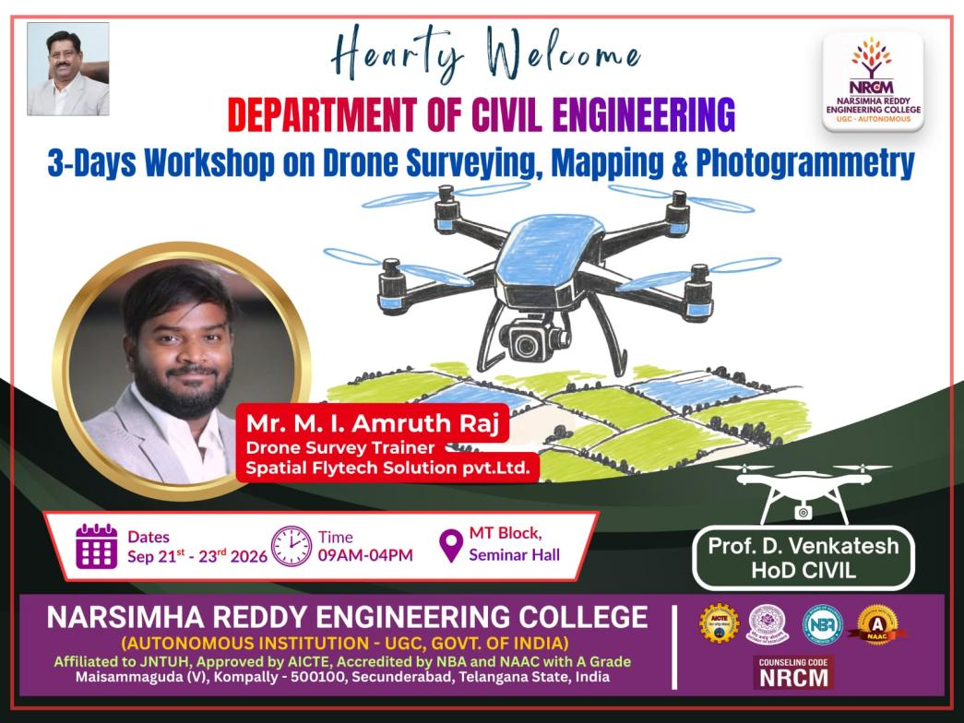
Event Photograph 1 |  | 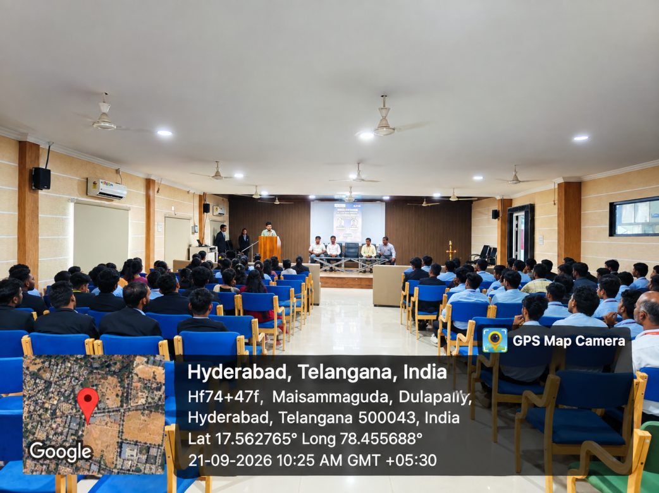
Event Photograph 2 |  | 